Task Prioritization
# Source: AI Source: Provided by: [Data Path: Persons Table -> ID Column: 1, Name_En Column: Motasem Essam] -> From: [ChatGPT] on [1/21/2026]
Task Prioritization is a fundamental concept in Real-Time Systems (RTS) and multitasking operating systems, where tasks are assigned different priorities to determine the order of execution. It ensures that critical tasks meet their deadlines while less critical tasks can wait.

Definition
# Source: AI Source: Provided by: [Data Path: Persons Table -> ID Column: 1, Name_En Column: Motasem Essam] -> From: [ChatGPT] on [1/21/2026]
Task prioritization is the process of assigning importance or urgency levels to tasks so that the scheduler knows which task to execute first.
- High-priority tasks get preferential access to the CPU or other resources.
- Low-priority tasks execute only when higher-priority tasks are idle or blocked.

Key Features
# Source: AI Source: Provided by: [Data Path: Persons Table -> ID Column: 1, Name_En Column: Motasem Essam] -> From: [ChatGPT] on [1/21/2026]
- Priority Levels
  - Can be static (fixed) or dynamic (changes at runtime).
  - Examples:
    - High → Critical control task
    - Medium → Monitoring task
    - Low → Background task
- Scheduling Integration
  - Works with preemptive and non-preemptive scheduling algorithms.
  - Ensures timely execution of high-priority tasks.
- Deadline Awareness
  - Often tasks with closer deadlines are assigned higher priority.
  - Used in algorithms like Rate Monotonic Scheduling (RMS) and Earliest Deadline First (EDF).

Example
# Source: AI Source: Provided by: [Data Path: Persons Table -> ID Column: 1, Name_En Column: Motasem Essam] -> From: [ChatGPT] on [1/21/2026]
Suppose a system has three tasks:
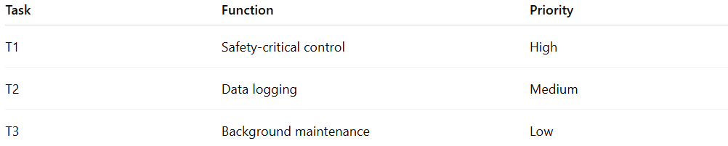
Task | Function | Priority
T1 | Safety-critical control | High
T2 | Data logging | Medium
T3 | Background maintenance | Low
- Execution Order: T1 → T2 → T3
- If T1 becomes ready while T3 is executing, T1 preempts T3 to meet its deadline.

Advantages
# Source: AI Source: Provided by: [Data Path: Persons Table -> ID Column: 1, Name_En Column: Motasem Essam] -> From: [ChatGPT] on [1/21/2026]
- Ensures critical tasks meet deadlines.
- Improves system responsiveness.
- Enables efficient CPU utilization by focusing on important tasks first.

Disadvantages
# Source: AI Source: Provided by: [Data Path: Persons Table -> ID Column: 1, Name_En Column: Motasem Essam] -> From: [ChatGPT] on [1/21/2026]
- Low-priority tasks may experience starvation.
- Requires careful priority assignment to prevent priority inversion.
- Complex in dynamic systems where priorities must adjust at runtime.

Why Task Prioritization Matters for Software Engineers
# Source: AI Source: Provided by: [Data Path: Persons Table -> ID Column: 1, Name_En Column: Motasem Essam] -> From: [ChatGPT] on [1/21/2026]
- Core principle for real-time and embedded system design.
- Helps schedule tasks efficiently and reliably in RTOS.
- Teaches how to balance system responsiveness and fairness among tasks.

